Multifaith Chapel & Library
reopens in new space
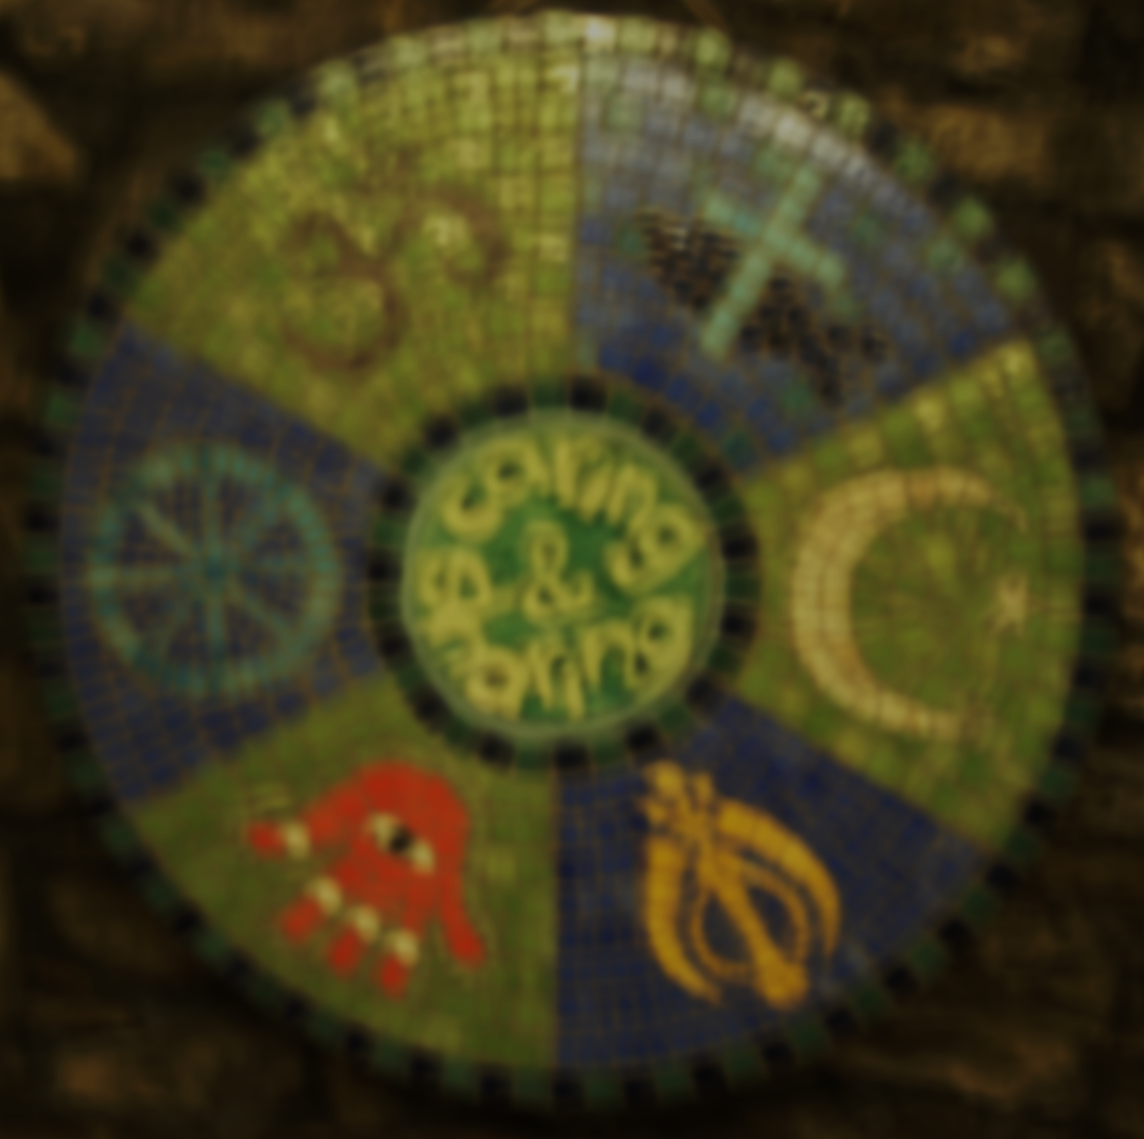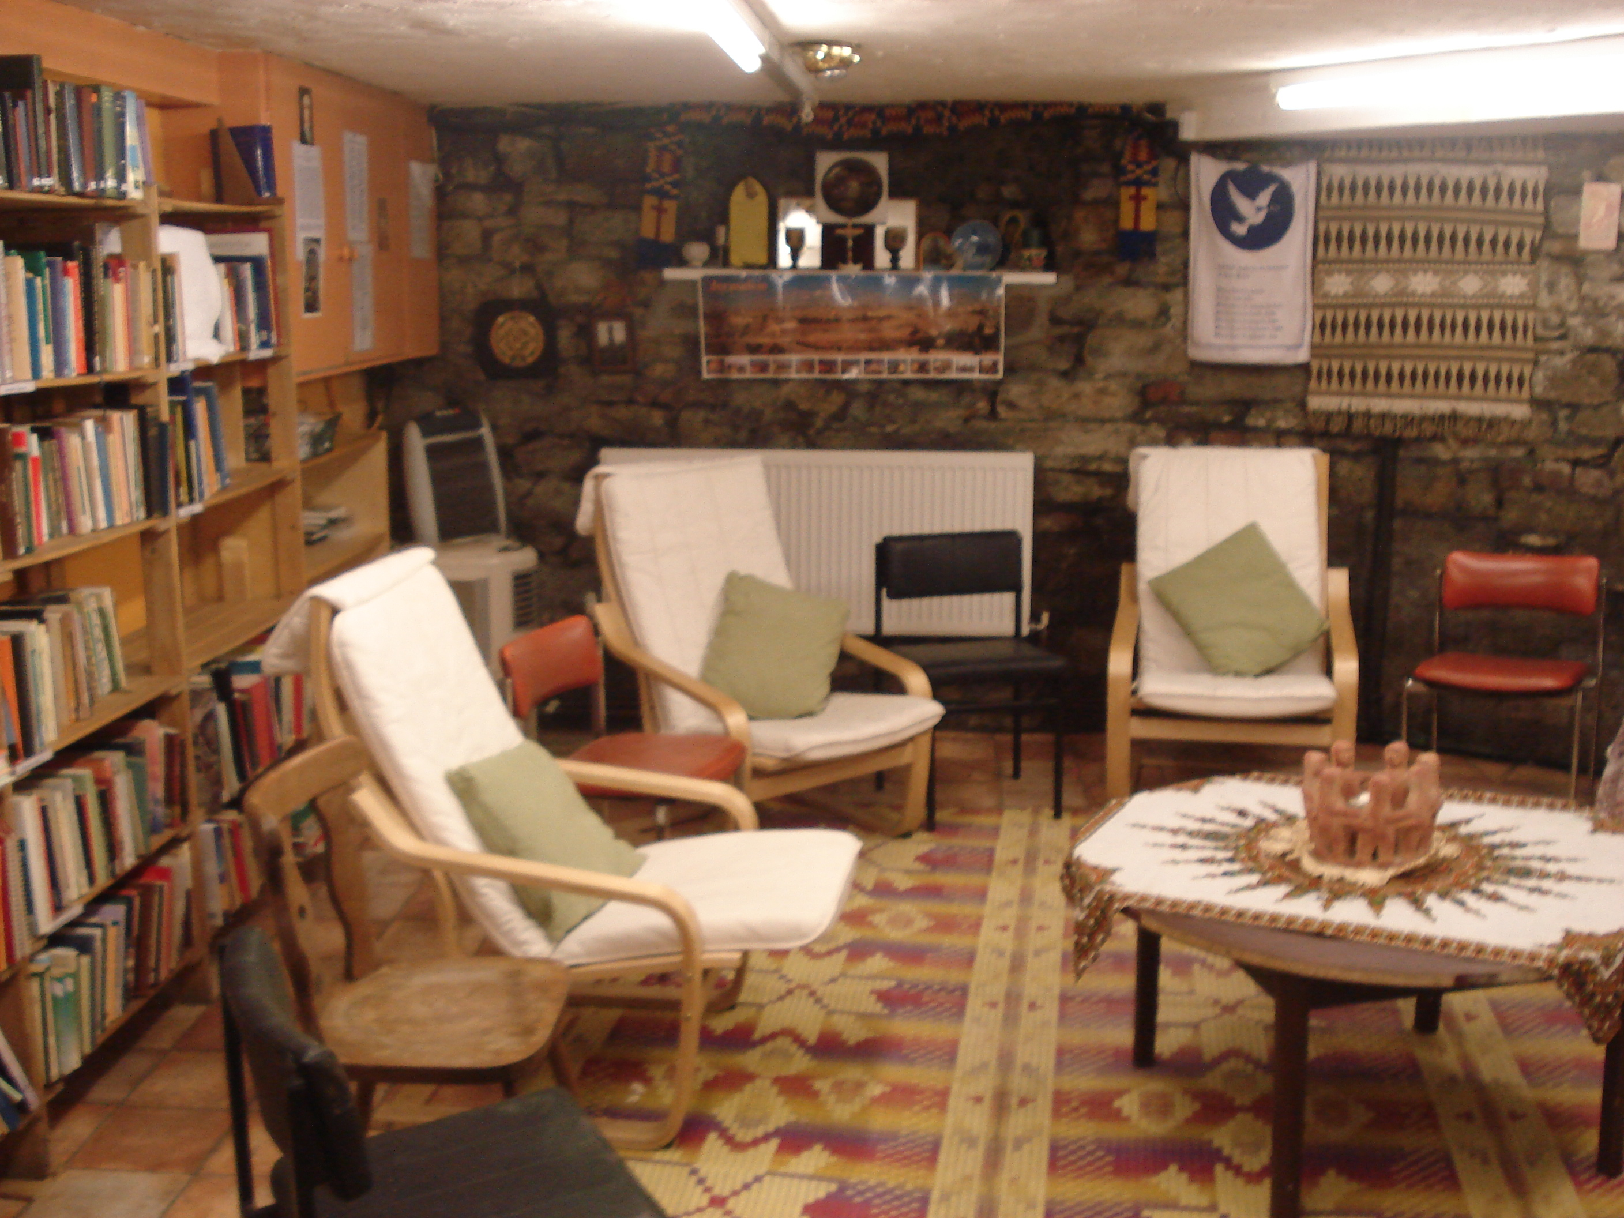

L: The large ceramic mosaic created by Burngreave Ashram’s Art Group with our motto: ‘Caring & Sharing’, depicting symbols of Christianity, Islam, Sikhism, Judaism, Buddhism and Islam; R: A part of the Multifaith Chapel & Library’s new home

The MCL at Burngreave Ashram has found a new home within the old building on Spital Hill. Thanks to the wise discernment and right view of our convenor/community leader, Rev Dr John Vincent, the MCL is now rehoused in much larger, more airy, brighter and less damp premises at Burngreave Ashram. Many of you will remember the little room down in the basement which perhaps did a bit more than its size represented, by involving various faiths in diverse events over the past 4 to 5 years. Some may well miss it! However, I’m personally delighted and feel blessed to have had the opportunity to see that ‘sacred’ space being given-up for others, particularly at a time when even sharing, let alone giving-up things, space and territory is fast becoming obsolete, while attachments to these recurrently cause hate and hostility. In ending let me say that it’s nothing but fitting, that MCL’s new home should be blessed by various faiths and reopened on 24th November in UK Interfaith Week 2012, given the exemplary role it has played in Sheffield’s celebrations of this annual national week since the first one in 2009.
- Nirmal Fernando (Organiser)

Burngreave Ashram
86 Spital Hill S4 7LG
(0114) 270 0972

